**Tutorial 24: Reaction Timer Game – Emitting Custom Events with Data**

In this tutorial we will be showing the user the reaction time that we get on the screen. We will pushing data from the child component to the parent component using emitting and display the output to the user.

Make sure **Tutorial 23** is complete to be able to move on to this tutorial or clone the [vue3-firebase-course](https://github.com/younggrasshopperza/vue3-firebase-course) repository and go to branch called **Tutorial-23**.

**Step 1:** In the **Block.vue** file, inside the **stopTimer** function after the **clearInterval**, create a custom emit called done and pass the **reactionTime** data property.

Look at the example below (**Line 41**):

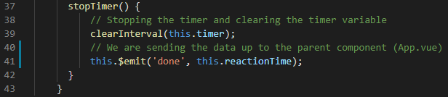

**Step 2:** In the **App.vue** file, create a data property called score with a value of null and create a data property called **showResults** with a value of **false**.

Look at the example below (**Between line 19 and 20**):

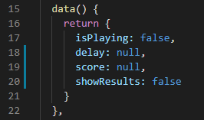

Inside the start function set **showResult** to **false**.

Look at the example below (**Between line 19 and 20**):

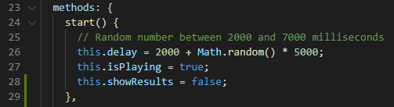

**Step 3:** In the **App.vue** file, we will be calling the emitted value. Create a function called **EndGame** that takes a parameter called **reactionTime**, the value passed up from **Block.vue**.

Set the score data property to the parameter, **reactionTime**. Set the **isPlaying** data property to false. Set the **showResult** data property to true.

Look at the example below (**Between line 30 and 34**):

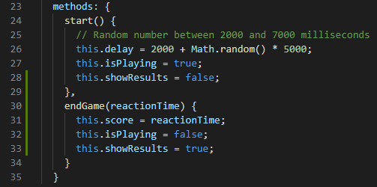

**Step 4:** In the **App.vue** file, called the emitted property called done in the Block component and assign the function endgame.

Create a paragraph that will be display the **score** data property to a user when the **showResults** is **true**.

Look at the example below (**Line 5**):

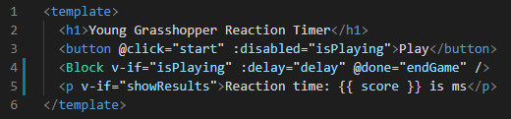

**Output:**

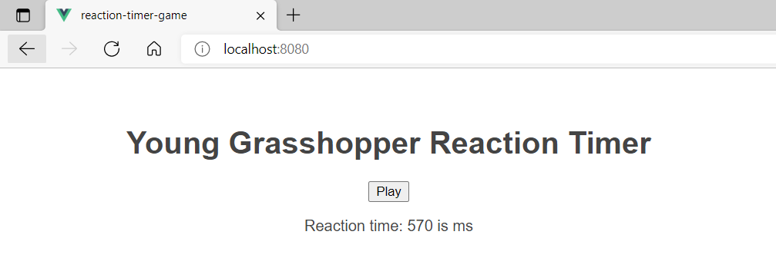

**You can view the code snippets from the** [**vue3-firebase-course**](https://github.com/younggrasshopperza/vue3-firebase-course) **repository under the Tutorial-24 branch**.